**SOFTWARE TESTING**

**(CSE 455)**

**LAB SELENIUM**

|  |  |
| --- | --- |
| **NAME:** | MUAAZ BIN MUKHTAR |
| **REG NO:** | FA21-BSE-045 |
| **CLASS & SECTION:** | BSSE-7A |
| **SUBMITTED TO:** | Mam Najmun Nisa |
| **DATE SUBMITTED:** | 25-12-2024 |



**Department of Computer Science**

**Task1:**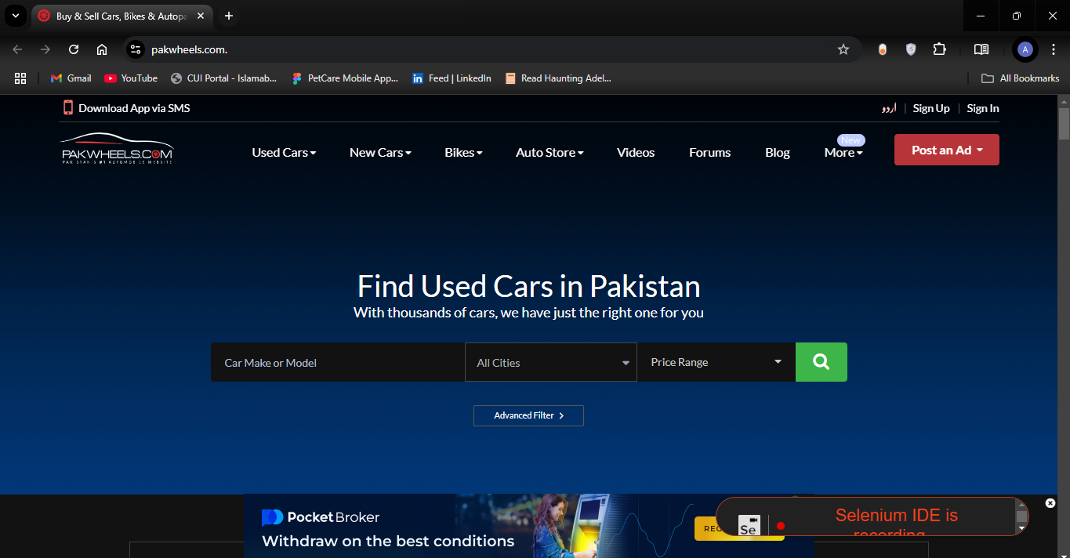

**Task 2:**

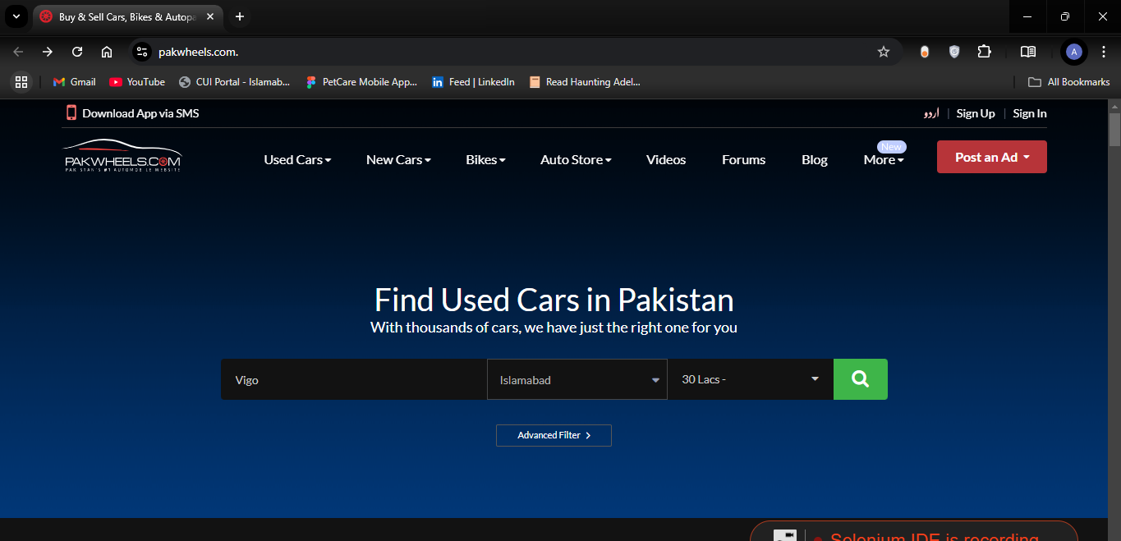

**Task 3:**

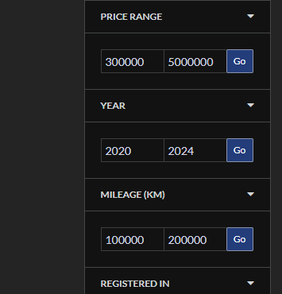

**Task 4:**

